Project Title: A Novel Method for Handwritten Digit Recognition System

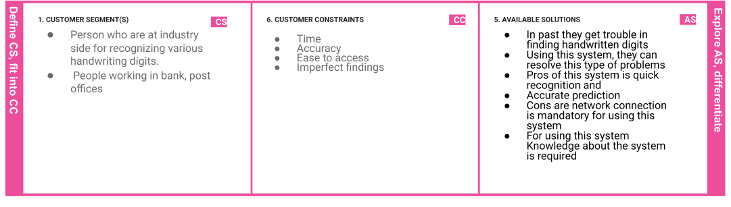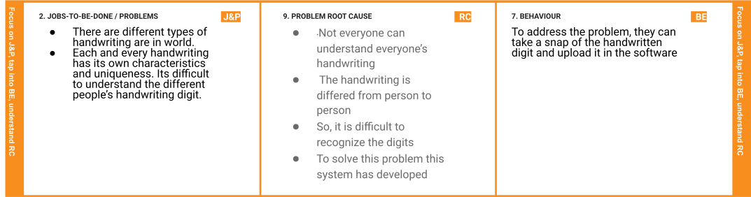

**Project Design Phase-I** - **Solution Fit Template Team ID:**  PNT2022TMID06505

|  |  |  |  |  |
| --- | --- | --- | --- | --- |
|  | 1. **TRIGGERS TR**    * By word of mouth    * Good user experience | 1. **YOUR SOLUTION SL**    * A novel method for handwritten digit recognition system helps in recognizing the handwritten digitsthat uses MNIST dataset for   training the model.   * + The model gets the image of the handwritten digits and recognizesthe handwritten digits.   + CNN algorithm is used over the MNIST dataset to recognize the handwritten digits. | 1. **CHANNELS of BEHAVIOUR**   **CH**   * 1. **ONLINE**   In online they can upload the handwritten picture and yield output   * 1. **OFFLINE**   In oﬄine they can ask their neighborsto scribble the digits to ﬁnd them |  |
| 1. **EMOTIONS: BEFORE / AFTER EM**    * It is a quite irritating and frustrating while manually convert the handwrittendigits    * • By using our system, user can save thetime and reduce the error occur on   recognition |